Automation/Control Logics for safe and efficient working of FFEs
By Khalid Rashid AL-Moiz Industries unit-II
khalid.rashid@almoiz.com
Abstract.
The main objective of the paper is to discuss the automation & control logics required for Falling Film Tubular evaporators operation. What are the potential benefits of these controls and why the same are necessary for the smooth running of FFE’s. How these controls improve the efficiency of the equipment and save from accidents like choking of tubes, entrainment etc. control logics required to maintain juice levels, emergency water, juice circulation flow, exhaust steam pressure and vapour temperature are discussed in the paper. How these controls help to make these evaporators monitoring easy and accessible. A review of the suitable instrumentation for better working and control is also a part of paper.
Introduction
This is well known fact that Almoiz Industries Limited is the pioneer as far as the complete set installation of Falling Film Evaporators to concentrate cane/beet juice is concerned. Almoiz has vast experience to run FFE’s successfully. Before this, the industry was based on the conventional Robert’s evaporators which are less efficient in terms of the steam economy and also the level of instrumentation and controls is not up to the mark and standards.
Automation & Control.
It is technique, method, or system of operating / controlling a process by highly automatic means to reduce the human intervention to a minimum. FFEs can be controlled by using PLC (Programmable Logic Controller) OR DCS (Distributed Control System), Devises used in these systems can be categorize as under,
- Field Instruments
These are the instruments used in the field such as level transmitters, temperature transmitters, flow meters, gauges etc. Selection of field instruments must be as per exact requirement of the process such as temperatures and pressures, spans and ranges should be precisely calculated for accurate results.
- Control Hardware
Control hardware means control system hardware. Generally we can select DCS/PLC to control the FFE’s. In DCS, a hierarchy of controllers is connected by communication network to command and monitoring. The elements of a DCS may connect directly to physical equipment such as switches, pumps and to operate interface screens. For control system selection, we must first calculate the requirement and type of I / OS. Redundancy may be adopted for more reliable operation.
PLC is a digital computer used for automation of typically industrial electromechanical process. Due to growth in technology adopted by PLC manufacturers; now a day’s PLC has enough capacity to control FFE’s. The PLC hardware and software are available and can be configured as per demand of FFEs control strategies.
- Control Software
DCS hardware needs a complete software solution. Software configuration/ Development must be done as per requirements of FFE’s. For this purpose developer must have adequate knowledge of control schemes. The human machine interfaces must be configured and implemented in a user friendly manner.
Equipments used for Control & Monitoring of Process in field.
- Level Transmitter (L.T)
- Pressure Transmitter (P.T)
- Temperature Transmitter (T.T)
- Flow Tube (F.T)
- Variable Frequency Drive (V.F.D)
- Control / on off valves
Types of equipments required.
Level Transmitter. Double Diaphragm, Capillary Type. Differential Pressure based.
Flow meter. Magnetic Flow meter type
Temperature Transmitter RTD based. Smart transmitter
Pressure Transmitter RTD based. Smart transmitter
Control Hardware & Software
Every manufacturer of Hardware generally provides software for configuration of control system and control strategy.
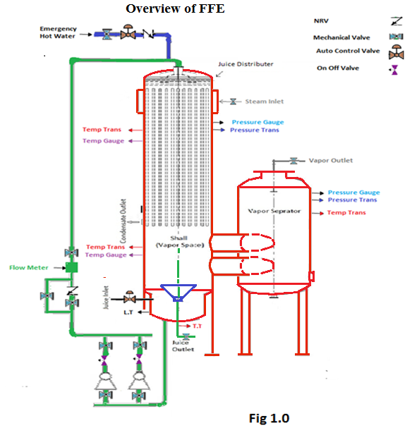
Juice Level control for circulation.
In FFEs thick juice outlet and thin juice inlet both are in the bottom of the evaporator and separation of both is only due to level differences .If thin juice level increases in the bowl of evaporator and mixes with thick juice (Fig.1.1), in such condition outlet brix of any evaporator cannot be maintained. So inlet juice level is very important to be maintained below the outlet juice level. There are two options to control inlet juice level in 1st evaporator
- By VFD of clear juice pump.
- By control valve in the inlet of evaporator.
Although the 1st option (a) can serve the purpose of the process but perfect control by VFD is difficult due to few reasons, one of them is placement of clear juice pumps which is normally far away from evaporators and variation in pump rpm does not fulfill the requirement properly, 2ndly clear juice heaters which are generally placed between clear juice pump and evaporators, due to any problem in juice heater can reduce the supply of juice in the evaporator or sudden excessive requirement of juice will increase the rpm of pump which will exert sudden pressures on the juice heaters and can cause leakages etc.
It is important to consider which logic for control is better, in option “a”, juice level will be controlled by change in frequency (change in rpm of pump) , in this case certain pressure has to maintain in the pipeline with respect to the vapor pressure in the evaporator to maintain the juice flow, but due to juice heaters between pumps and evaporators this balance of pressure may disturb due to no. of heaters, its passes, and requirement of juice in evaporator etc. sometimes if evaporator needs more juice to maintain the level ,rpm of the pump increases which rapidly increases the pressure in the system and if it increases from a certain limit i.e. above 5-8 kg/cm² can put huge pressure on top and bottom covers of tubular heaters which can cause leakages in heaters, on the other hand if juice level increases above the given limit ,rpm of pump will reduce to maintain it and due to very short retention time(short volume of juice bowl) and long distance, make it difficult to control the juice level in the evaporator and practically frequency ups and downs rapidly and level of juice cannot be maintained properly.
Clear juice Frequency control with respect to pressure in the pipe line.
It is better to have clear juice pump control with respect to the pressure of vapours in the vassel, in this way pressure in the delivery line will be maintained by VFD, resulting in constant supply of juice to the evaporator. In case of failure of clear juice pump stand by pump should operate automatically to maintain required juice pressure in the line.
Juice level control by control valve in the juice inlet of evaporator.
The best option to control juice level in 1st and other evaporators is to put control valve in the inlet juice pipe line of evaporator as near as possible.
Main Reasons of juice level disturbance in evaporator.
Fault in VFD or motor of clear juice pump.
Any issue with on/off valves in the delivery valves of clear juice pumps.
Any problem in clear juice heaters just as choking etc.
Any fault in inlet control valve.
Any problem in the level transmitters.

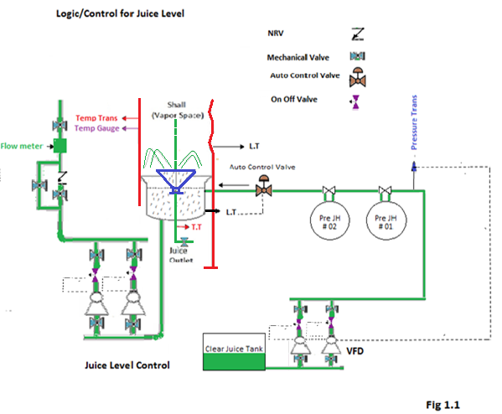Circulation Juice Flow Control.
In FFEs adequate supply of juice to the tubes is most important for proper wetting of tubes. If it is not properly controlled rapid fouling/ choking of tubes can happen. To maintain juice circulation flow, following equipment / control and logics are necessary
1. Pumps according to the juice circulation capacity with VFDs.
2. Juice flow meter to measure juice circulation flow.
3. On /off valves in the delivery of juice circulation pumps.
4. Provision of emergency water supply.
5. Inlet control valve for juice.
Reasons of circulation juice flow reduction
- Failures of juice circulation pump electrically.
- Failures of juice circulation pump mechanically.
- Failure of VFD.
Under all above situations juice circulation flow will reduce and when it reaches to the 50% of the required quantity 2nd pump (stand by) should immediately start to fulfill the requirement of circulation juice, for this purpose it is necessary to have on/off butterfly valves in the delivery of juice pumps which will automatically operate according to the logics.
There may be another reason that inlet juice get short in the juice bowl of the evaporator, in this case 1st of all inlet juice control valve should open fully to maintain required quantity of juice, and if it does not serve the purpose and juice circulation reduces to 50% of its required quantity emergency water valve should open to fulfill the requirement.
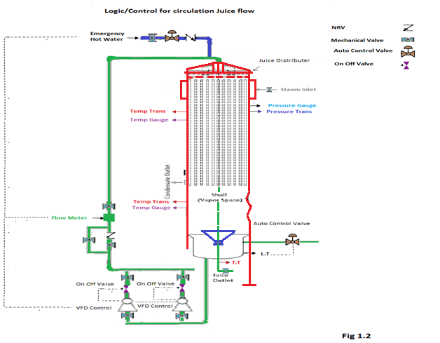
Emergency Water Arrangement
In FFEs mostly all arrangements are done to maintain wetting of tubes, in case juice gets short in the tubes, will result in rapid fouling of tubes and in extreme, choking of tubes. Following arrangements are required for emergency water.
- In let of emergency water/ valves arrangement
Supply of emergency water should be at the same place from where circulation juice is supplied. Arrangement of Emergency water valves should be in this way (fig. 1.3),
Mechanical valve, on / off butterfly valve then non return valve.
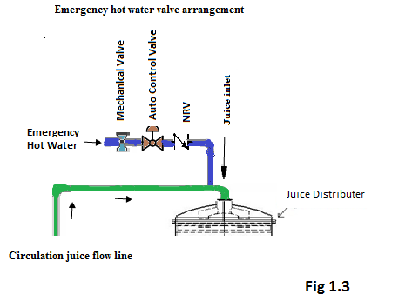
Mechanical valve remains open during operating ,when the flow transmitter indicates low juice flow or zero juice flow in case of shutdown or VFD failure then on/ off valve operates & emergency hot water enters in the evaporator to fulfill the shortage of juice or wetting of tubes in case of shut down..
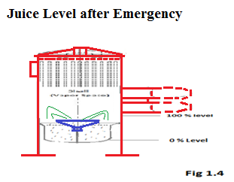
- Emergency over head hot water Tank Placement.
Placement of overhead emergency hot water tank needs special attention; it should be placed in such a way that water head always remain more than the vapour pressure in the evaporator. suppose top of the evaporator is 23 m and vapour pressure is 1 kg/cm² the requirement of water head will be minimum 33 m, more safely 35-38 m.
Water Circulation pump can also be used for this purpose but it is suitable only during normal operation in case of shutdown overhead tank is the safest arrangement.
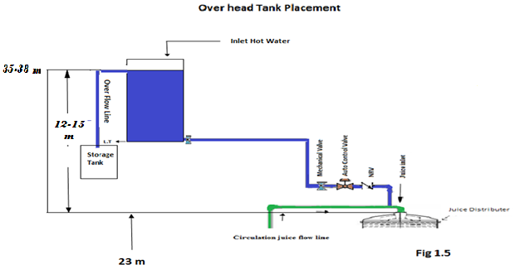
- Emergency over head hot water Volume/Capacity
Overhead tank storage should be so much that in an emergency condition tank could supply hot water to all operational Evaporators to a certain level. Almost Hot water tank of 100 m³ is sufficient for quintuple effect.
Safety in case of high exhaust steam pressure.
In case, exhaust steam pressure increases to a limit, to avoid tripping of steam turbine or any other damages, proper safety arrangement are necessary, There may be few reasons of high back pressure, Sudden juice shortage in the evaporator due to any reason, fouling of evaporator tubes and sudden shutdowns.
To maintain exhaust steam pressure, safety valve in the exhaust line is required, It may be controlled by on/off valve , its set point for opening and closing has to be given through DCS keeping in view the working exhaust steam pressure and designed value of back pressure of steam turbine. If working pressure for a set of FFEs is considered 1.5-1.6 kg/cm² and turbine is designed at 2.0 Kg/cm² than set point for safety valve can be given as
Opening at 1.7-1.8 Kg/cm²
Closing at 1.4-1.5 Kg/cm²
In this case capacity of valve need to be considered carefully, if that is undersize can make problems to maintain pressure.
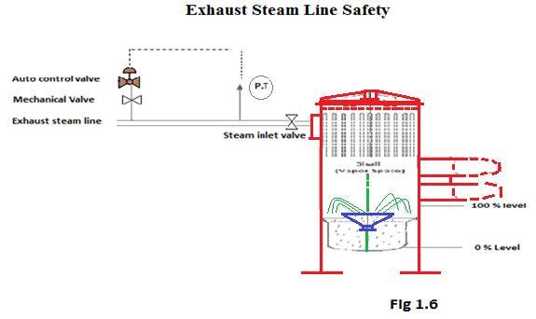
Temperature Control of Exhaust Steam.
Exhaust Steam temperature is controlled through desuper heating system, it is normally applied in two stages for better and accurate control, in 1st stage live steam is desuperheated to the temp. Of turbine exhaust steam, in 2nd stage combined steam from live steam & turbine is desuperheated to the required temp for boiling.
Temperature Control of Vapors.
Temp. Control of vapors is necessary to get maximum vapour bleeding up to last affect, temp. Of vapour is directly proportional to the pressure, It means to maintain temp. Pressures have to maintain respectively. The only way to control the pressure of every vapour is to control vacuum in the last effect relatively and vapour bleeding to some extent. If vacuum increases in last effect to the required value ultimately all pressures will get down and temperature too. To maintain vac. Condenser of last evaporator should be on auto.
By maintaining vacuum15-18 inches of Hg (-0.5 to -0.6 kg/cm²) for last effect in quintuple effect following temperatures of vapors can be maintained.
1st vapor temperature = 115-118 °C
2nd vapor temperature=108-110 °C
3rd vapor temperature=100-101 °C
At these temperatures 2nd and 3rd vapours can be use for juice heaters and pans.
CONCLUSIONS.
- Automation & control make falling film operation easy & efficient.
- Selection of right size / quality instrument is necessary.
- Central control system made monitoring easy/ facilitate recording.
Operational logics in FFE’s are important to be maintained.
- Juice level control for circulation.
- Juice circulation flow control.
- Emergency hot water arrangements.
- Exhaust steam safeties.
- Temperature control of vapors.
References
Cane Sugar Engineering by Peter Rein, Page 290,292,300
Sugar Technology by P. W .Van Der Poel, H. Schiweck and T. Schwartz, Page 639,640
https://www.agriculture-xprt.com/products/falling-film-evaporator-324964
http://automators.com.pk/sugar-mill?a=film
Acknowledgment.
The author thanks to Mr.Nauman Ahmed Khan who provided facilities to get trainings in advance technologies in Pakistan and abroad. To Mr.Haider Jabbar Khan for his guidance throughout preparation of paper to Mr. M. Shahid DPM (P),Mr. Zia Hussain APM (Inst), Mr. Salman Shehryar(DGM) and Mr. Irfan (Sr. Chemist) in helping to collect data and in managing all details of paper.

